 | Interior | Interior | Exterior
Interior |  |  | 
Boundary |  |  | 
Exterior |  |  | 

 | Interior | Interior | Exterior
Interior |  |  | 
Boundary |  |  | 
Exterior |  |  | 

 | Interior | Interior | Exterior
Interior |  |  | 
Boundary |  |  | 
Exterior |  |  | 

 |  | B
 |  | Interior | Boundary | Exterior
A | Interior |  |  | 
 | Boundary |  |  | 
 | Exterior |  |  | 
Transpose
 |  | B
 |  | Interior | Boundary | Exterior
A | Interior |  |  | 
 | Boundary |  |  | 
 | Exterior |  |  | 
Inverted A
 |  | B
 |  | Interior | Boundary | Exterior
A | Interior |  |  | 
 | Boundary |  |  | 
 | Exterior |  |  | 
Inverted B
 |  | B
 |  | Interior | Boundary | Exterior
A | Interior |  |  | 
 | Boundary |  |  | 
 | Exterior |  |  | 

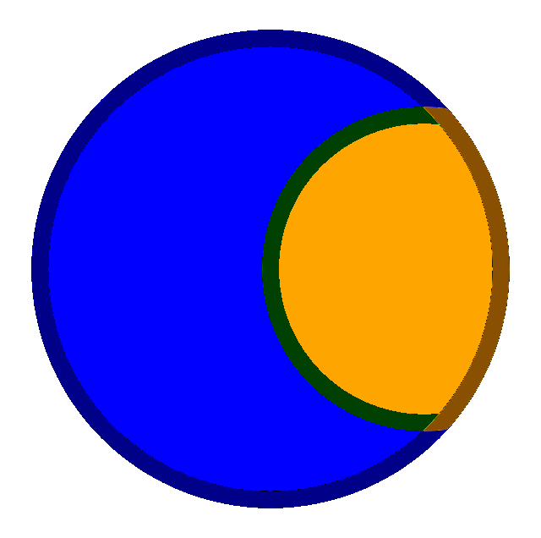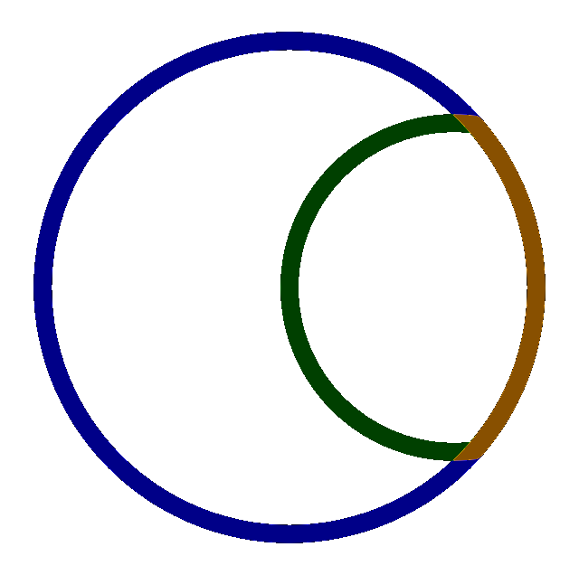
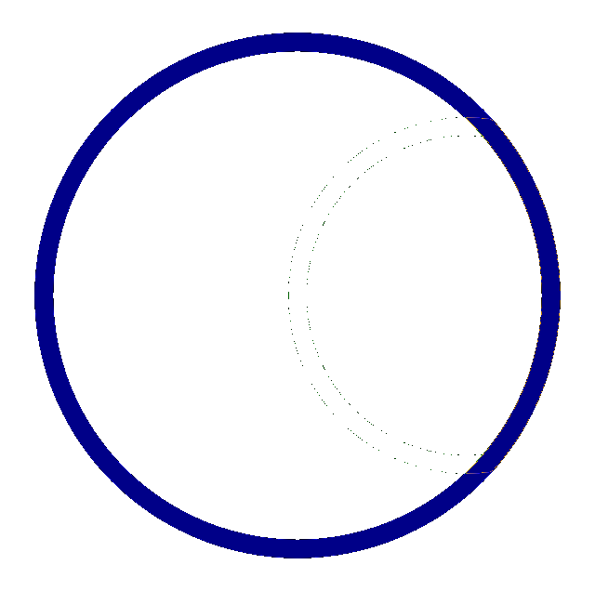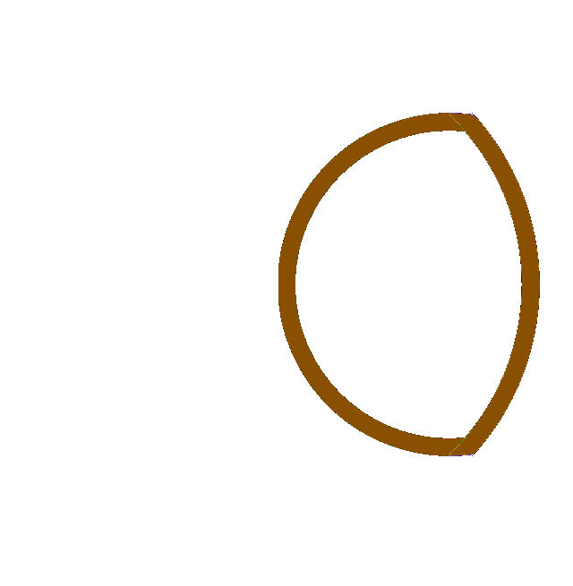

Shape components
 |  | Shape A | Shape B
Original solid polygon | Original |  | 
Define an exterior margin | Full Interior | 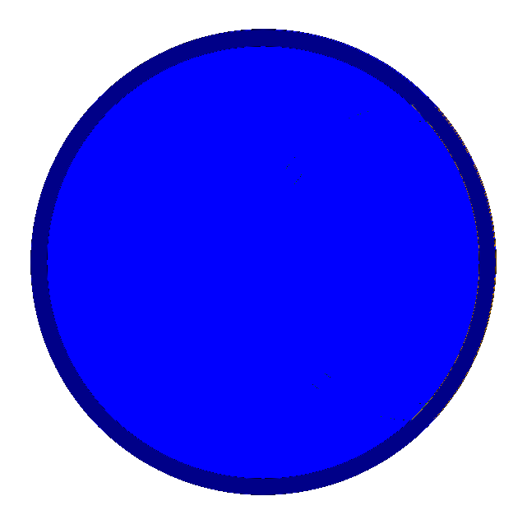 | 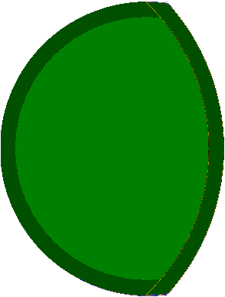
Subtract that margin from the shape | True Interior |  | 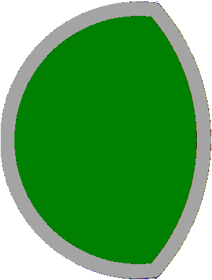
Extract just the margin | Boundary | 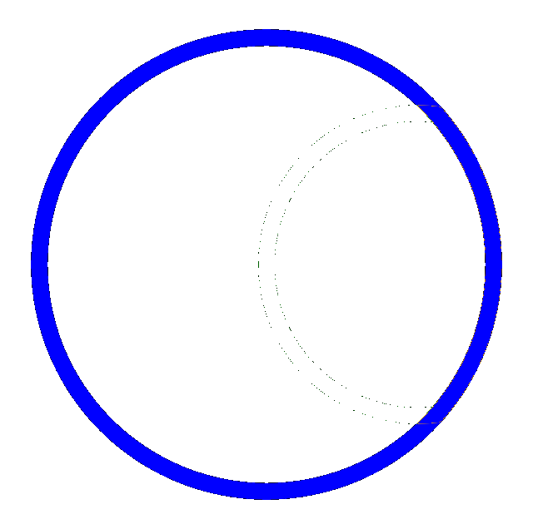 | 
Inverse of Full Interior | True Exterior | 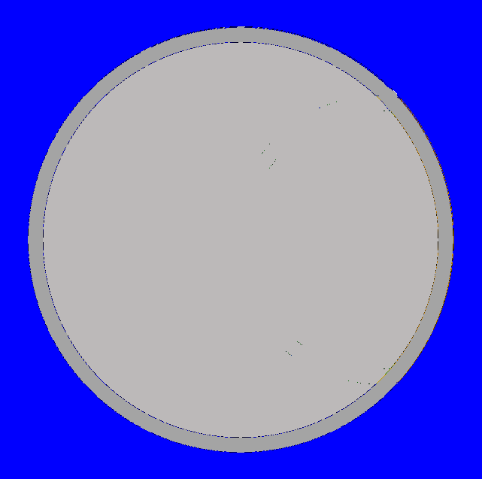 | 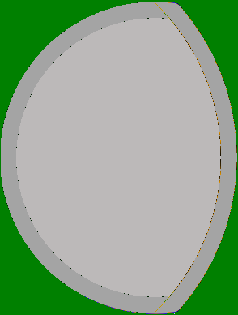

B is smaller than A  Overlap shown in Orange |  |  | B
 |  |  |  |  | 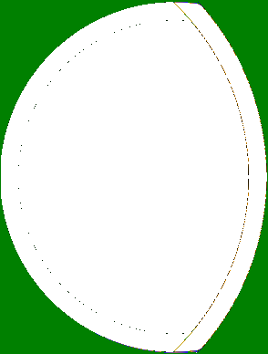
 |  |  | True Interior | Boundary | True Exterior
A |  | True Interior |  |  | 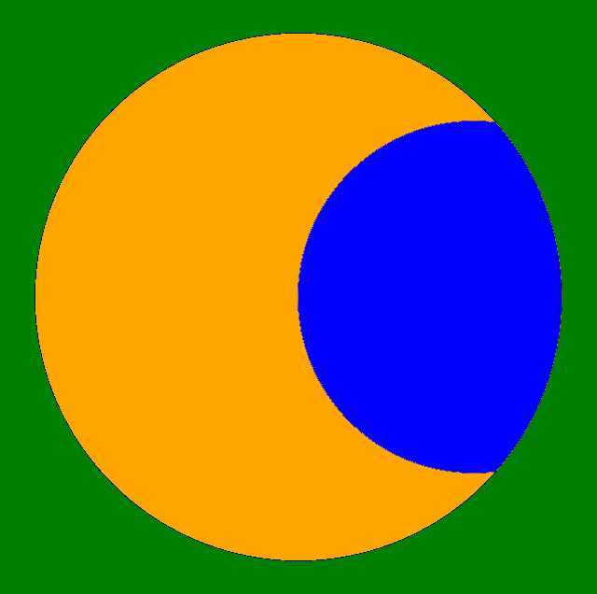
 |  | Boundary | 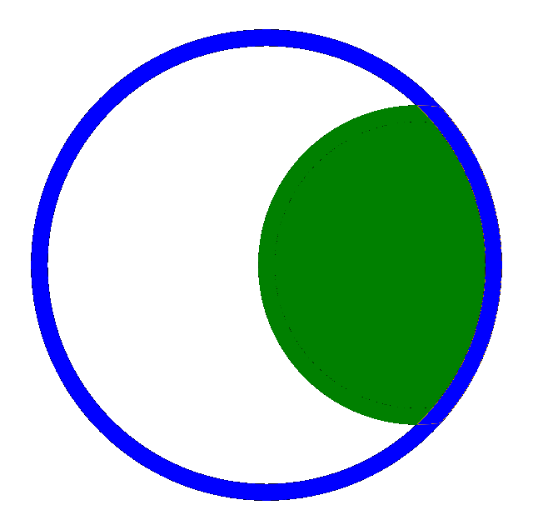 | 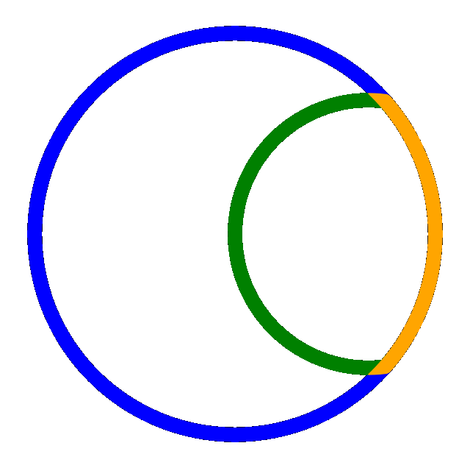 | 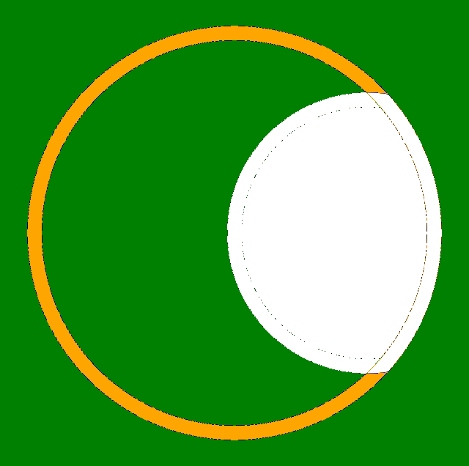
 | 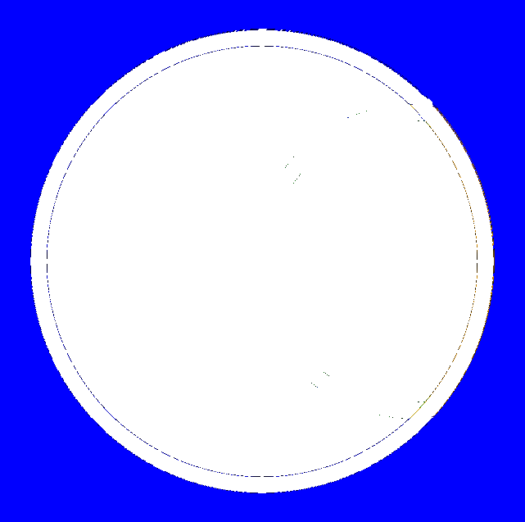 | True Exterior |  |  | 

$$\begin{matrix} & \text{True Interior} \\ \text{True Interior} & \left[\begin{matrix}∩ & * & * \\ * & * & * \\ * & * & *\end{matrix}\right]\end{matrix}$$
$$\begin{matrix} & \text{True Interior} \\ \text{Boundary} & \left[\begin{matrix}∩ & * & * \\ * & * & * \\ * & * & *\end{matrix}\right]\end{matrix}$$
$$\begin{matrix} & \text{True Interior} \\ Full Interior & \left[\begin{matrix}* & * & * \\ * & * & * \\ ⊄ & * & *\end{matrix}\right]\end{matrix}$$
B is smaller than A  Overlap shown in Orange |  |  | B
 |  |  |  |  | 
 |  |  | True Interior | Boundary | True Exterior
A |  | True Interior | $$\left[\begin{matrix}∩ & * & * \\ * & * & * \\ * & * & *\end{matrix}\right]$$ |  | 
 |  | Boundary |  |  | 
 |  | Full Interior |  |  | 

2D Relationship Matrix (DE-9IM)
DE-9IM is used to describe the spatial relations between two geometries in two-dimensions. The DE-9IM model is based on a 3×3 intersection matrix with the form below, where dim is the dimension of the intersection of the interior (I), boundary (B), and exterior (E) of geometries a and b:
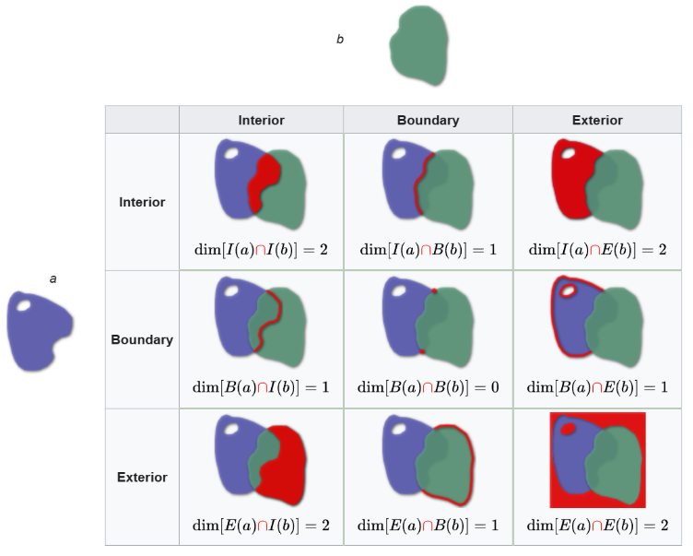
Some examples of defined relationships are:
Name | DE-9IM | Meaning and definition
Disjoint | $$\left[\begin{matrix}F & F & * \\ F & F & * \\ * & * & *\end{matrix}\right]$$ | a and b have no points in common.
Overlaps | $$\left[\begin{matrix}2 & 1 & 2 \\ 1 & * & 1 \\ 2 & 1 & *\end{matrix}\right]$$ | a overlaps b: they have some but not all points in common.
Within | $$\left[\begin{matrix}2 & * & F \\ * & F & F \\ * & * & *\end{matrix}\right]$$ | a lies in the interior of b.

